A Dichotomous Key to Pamishan Creatures
1. | a. The creature has a large wide head............................go to 2
 | b. The creature has a small narrow head..........................go to 11
2. | a. It has 3 eyes ................................................go to 3
 | b. It has 2 eyes ................................................go to 7
3. | a. There is a star in the middle of its chest....................go to 4
 | b. There is no star in the middle of its chest ..................go to 6
4. | a. The creature has hair spikes .................................Broadus hairus
 | b. The creature has no hair spikes...............................go to 5
5. | a. The bottom of the creature is arch-shaped ....................Broadus archus
 | b. The bottom of the creature is M-shaped .......................Broadus emmus
6. | a. The creature has an arch-shaped bottom .......................Broadus plainus
 | b. The creature has an M-shaped bottom...........................Broadus tritops
7. | a. The creature has hairy spikes ................................go to 8
 | b. The creature has no spikes....................................go to 10
8. | a. There is a star in the middle of its body ....................Broadus hairystarus
 | b. The is no star in the middle of its body .....................go to 9
9. | a. The creature has an arch shaped bottom .......................Broadus hairyemmus
 | b. The creature has an M shaped bottom ..........................Broadus kiferus
10. | a. The body is symmetrical ......................................Broadus walter
 | b. The body is not symmetrical...................................Broadus anderson
11. | a. The creature has no antennae .................................go to 12
 | b. The creature has antennae ....................................go to 14
12. | a. There are spikes on the face .................................Narrowus wolfus
 | b. There are no spikes on the face ..............................go to 13
13. | a. The creature has no spike anywhere ...........................Narrowus blankus
 | b. There are spikes on the right leg ............................Narrowus starboardus
14. | a. The creature has 2 eyes.......................................go to 15
 | b. The creature has 1 eye........................................Narrowus cyclops
15. | a. The creature has a mouth......................................go to 16
 | b. The creature has no mouth.....................................go to 17
16. | a. There are spikes on the left leg .............................Narrowus portus
 | b. There are no spikes at all ...................................Narrowus plainus
17. | a. The creature has spikes ......................................go to 18
 | b. The creature has no spikes ...................................Narrowus georginia
18. | a. There are spikes on the head .................................go to 19
 | b. There are spikes on the right leg.............................Narrowus montanian
19. | a. There are spikes covering the face ...........................Narrowus beardus
 | b. There are spikes only on the outside edge of head ............Narrowus fuzzus

Taxonomy, Classification, and Dichotomous Keys
Help! Scientists have discovered quite a few new creatures on planet Pamishan. They need your help to identify and classify them. Use the dichotomous key on the next page to identify these creatures. Write your answers on a piece of notebook paper.
1. 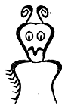 | 2. 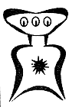 | 3. 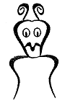 | 4. 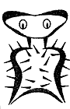 | 5. 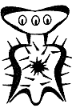
6. 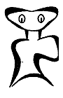 | 7. 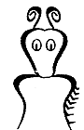 | 8. 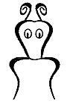 | 9. 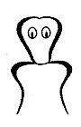 | 10. 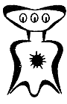
11. 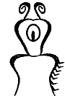 | 12. 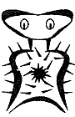 | 13. 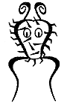 | 14. 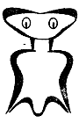 | 15. 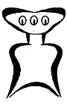
16. 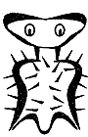 | 17. 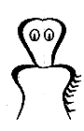 | 18. 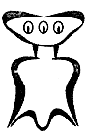 | 19. 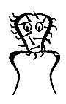 | 20. 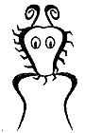

Pamishan Answers
1. __________________________________
2. __________________________________
3. __________________________________
4. __________________________________
5. __________________________________
6. __________________________________
7. __________________________________
8. __________________________________
9. __________________________________
10. __________________________________
11. __________________________________
12. __________________________________
13. __________________________________
14. __________________________________
15. __________________________________
16. __________________________________
17. __________________________________
18. __________________________________
19. __________________________________
20. __________________________________

