The newest organisms, meaning they have been on Earth the shortest amount of time, are at the top.
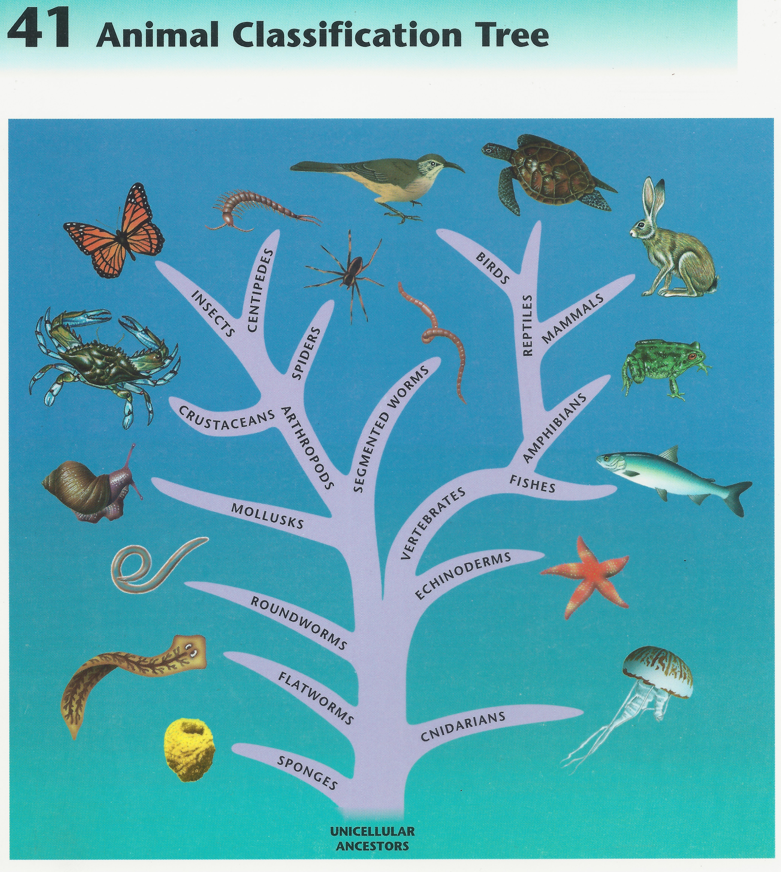
The oldest organisms, meaning they have been on Earth the longest, are at the bottom.
The closer the branches are to each other, the more those types of organisms have in common. They are more closely related.

Start at the branch the question asks you about, then drag your finger to the other options. Which one did you come to first? It is the one that is more closely related.
- According to the classification tree, which of these is more closely related to

birds -- mammals or reptiles? reptiles

How do you know? The reptiles branch is closer to birds than the mammals branch.

- According to the classification tree, which of these is more closely related to

mollusks – segmented worms or spiders? ______________________________________

How do you know? _____________________________________________________________

- Put the following in the order in which they evolved: echinoderms, amphibians, spiders, flatworms, birds, and roundworms.
A. flatworms B. ______________________________,
C. ______________________________, D. ______________________________,
E. ______________________________, F. birds

