Endocrine System Notes
Functions of Endocrine Glands
- Produce hormones that assist in the processes of our body.
- Made of glands
- The endocrine glands include the hypothalamus, pituitary, thyroid, parathyroid, adrenal, thymus, and pancreas.
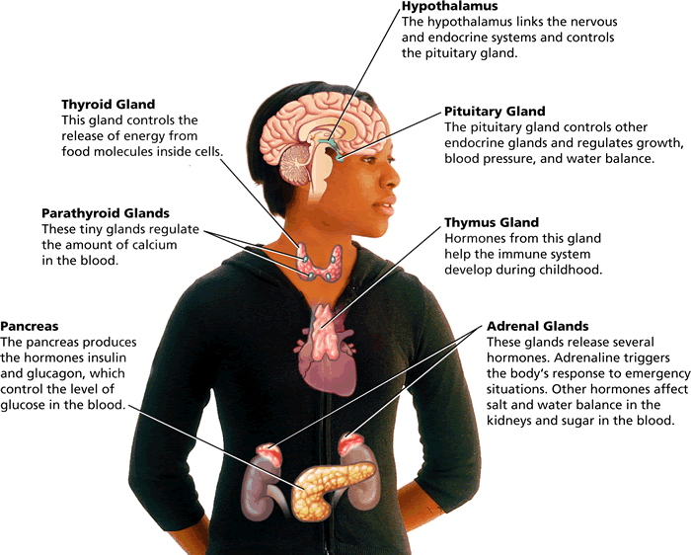
- The ovaries in females and testes in males are also endocrine glands.
- Ovaries release estrogen and testes release testosterone.

Negative Feedback

- Through negative feedback, when the amount of a particular hormone in the blood reaches a certain level, the endocrine system sends signals that stop the release of that hormone.

