Evidence of Evolution
Fossils, patterns of early development, and similar body structures all provide evidence that organisms have changed over time.
- Homologous Body Structures - Structures that have different mature forms but develop from the same embryonic tissues.
- Vestigial Organs - traces of homologous organs in other species where the organ serves no useful function (Appendix in humans)
- Similarities in Embryology - In their early stages of development, chickens, turtles and rats look similar, providing evidence that they shared a common ancestry.
Scientists have combined evidence from DNA, protein structure, fossils, early development, and body structure to determine the evolutionary relationships among species.
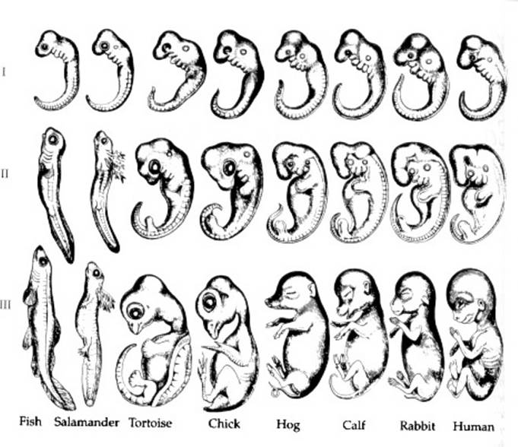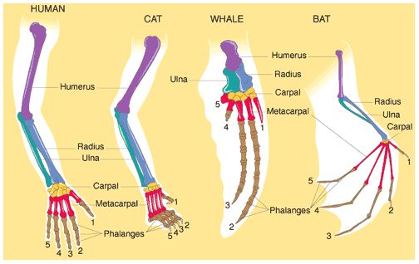
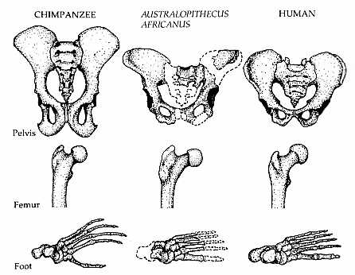
A new species can form when a group of individuals remains isolated from the rest of its species long enough to evolve different traits.
- Geographic Distribution of Living Species - Similar animals in different locations were the product of similar lines of descent.
The Fossil Record
Most fossils form when organisms that die become buried in sediments.
- Specific environmental conditions are necessary in order for fossils to form.
  - Permineralization occurs when minerals carried by water are deposited around a hard structure.
  - A natural mold forms when flowing water removes all of the original tissue, leaving an impression. The cast is the copy of the shape of the organism that makes the mold.

  - Trace fossils record the activity of an organism.
  - Amber-preserved fossils are organisms that become trapped in tree resin that hardens after the tree is buried.
  - Preserved remains form when an entire organism becomes encased in material such as ice.
- Only a tiny percentage of living things became fossils.
Scientists can determine a fossil’s age in two ways: relative dating and radioactive dating.
- Relative Dating - Can determine a fossil’s relative age
  - Performed by estimating fossil age compared with that of other fossils
  - It compares the placement of fossils in layers of rock.
  - Scientists infer the order in which species existed.
  - Drawbacks – provides no info about age in years
- Radioactive Dating – also known as Absolute Dating
  - Can determine the absolute age in numbers
  - Is performed by radioactive dating – based on the amount of remaining radioactive isotopes remain (measured in a half-life)
  - Half-life: the amount of time it takes for ½ of the isotope to decay
  - Drawbacks - part of the fossil is destroyed during the test
The calendar of Earth’s history is sometimes called the Geologic Time Scale.
- Time divided into major past events.
- Eras last tens to hundreds of millions of years.
- Periods last tens of millions of years.
  - most commonly used units of time on time scale
  - associated with rock systems.
- Epochs last several million years.

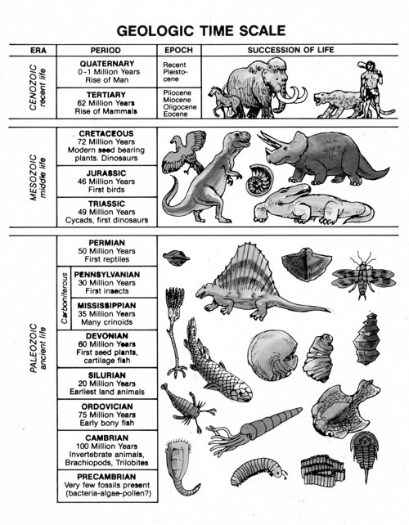
- Precambrian period lasted approximately 4 billion years.
Scientists still do not completely understand the causes of mass extinctions and the rate at which evolution occurs.
- Gradualism – evolution occurs slowly but steadily. Tiny changes in a species gradually add up to major changes over time.
- Punctuated Equilibria – species evolve quickly during relatively short periods. These periods of rapid change are separated by long periods of little to no change.

