Immune System Notes
What is the immune system?
- The body’s defense against disease causing organisms, malfunctioning cells, and foreign particles

The First Line of Defense
  - The skin, mucus, saliva, and stomach acid

The Second Line of Defense
  - The Inflammatory Response: results in the release of white blood cells called phagocytes
The Third Line of Defense
~The Immune Response~
  - The cells of the immune system can distinguish between different kinds of pathogens. The cells react to each kind of pathogen with a defense targeted specifically at that pathogen.
  - A pathogen is an organism that causes a disease.
  - White blood cells that can distinguish between different pathogens are called lymphocytes.
  - T-Cells, a type of lymphocyte, can identify pathogens and distinguish one kind from another.
  - T-cells will attack these infected cells, quickly kill them, and then continue to search for more cells to kill
  - T-cells look for antigens, which are markers on the cells so that the T cell can recognize that cell as being a pathogen or part of your body
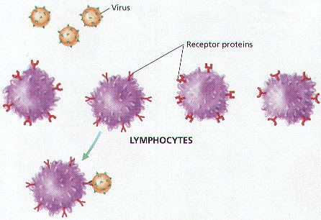

  - Lymphocytes called B cells produce proteins that help destroy pathogens. These proteins are called antibodies.
  - Proteins that latch onto, damage, clump, and slow foreign particles
  - Each antibody binds only to one specific binding site, known as an antigen
  - When antibodies bind to the antigen of a pathogen, they mark that pathogen for destruction.

