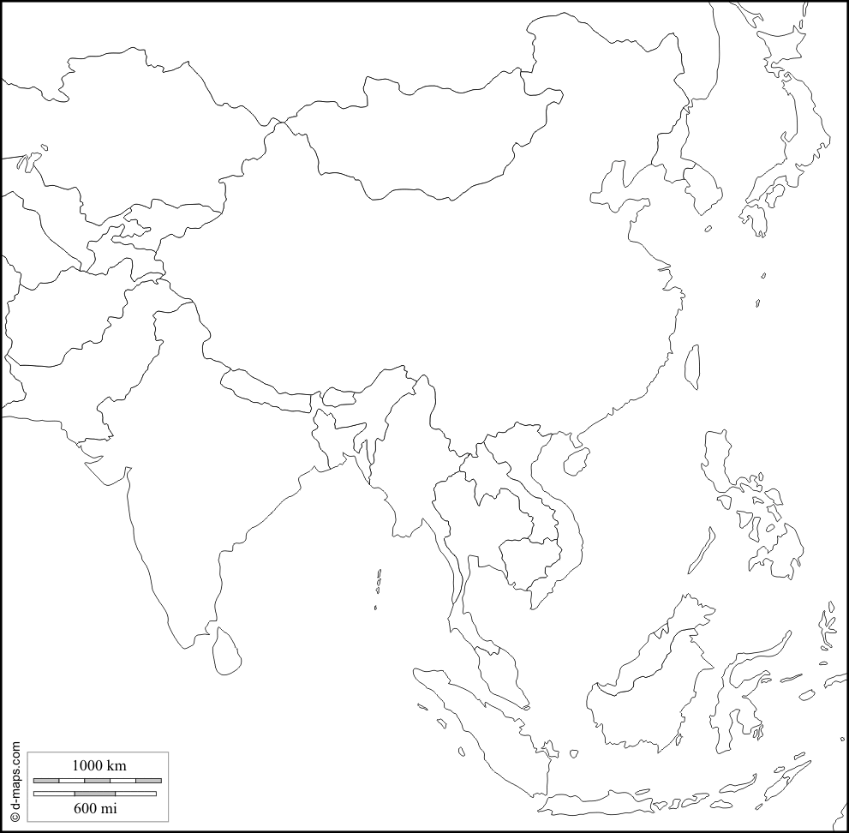

**Label each of these countries: China, India, Indonesia, Japan, North Korea, South Korea Vietnam**

**Color each country a different color.**

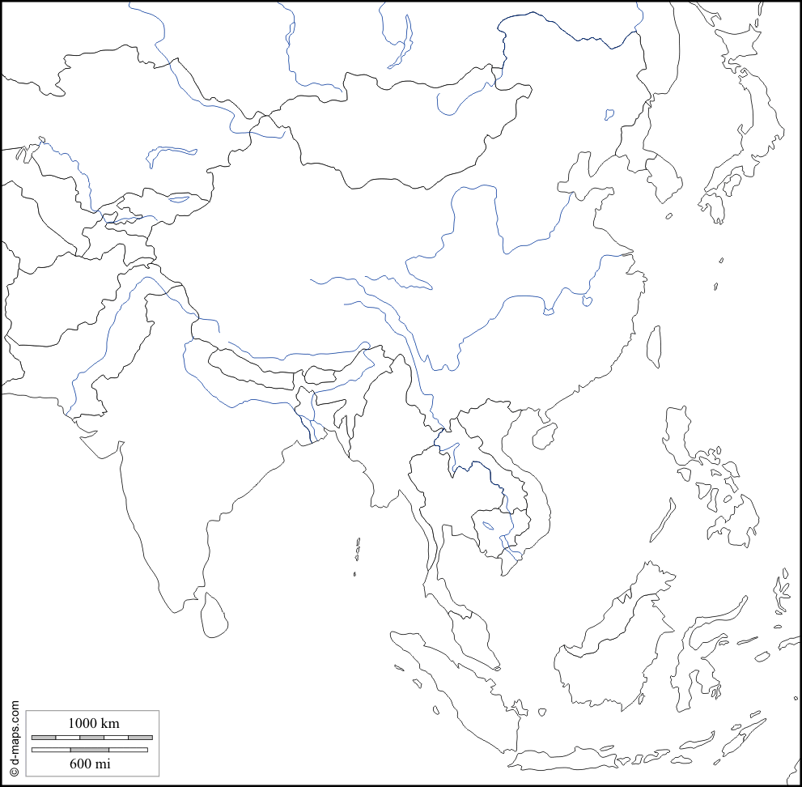

Label these physical features: Ganges River, Huang He (Yellow River), Indus River, Mekong River, Yangtze (Chang Jiang) River, Bay of Bengal, Indian Ocean, Sea of Japan, South China Sea, Yellow Sea, Gobi Desert, Taklimakan Desert, Himalayan Mountains, Korean Peninsula

Trace the rivers with a blue **color pencil/crayon/marker.** Color the Bay, ocean, and seas **blue**. Color the deserts **yellow**. Draw the Himalayan Mountains using an upside down “V.” Color the Korean Peninsula **green**.