Africa’s Ethnic Groups
Directions: Locate and color the ethnic groups of Africa (Arab, Ashanti, Bantu, & Swahili) on the map of Africa below. Be sure to make a color-coded key for the map.
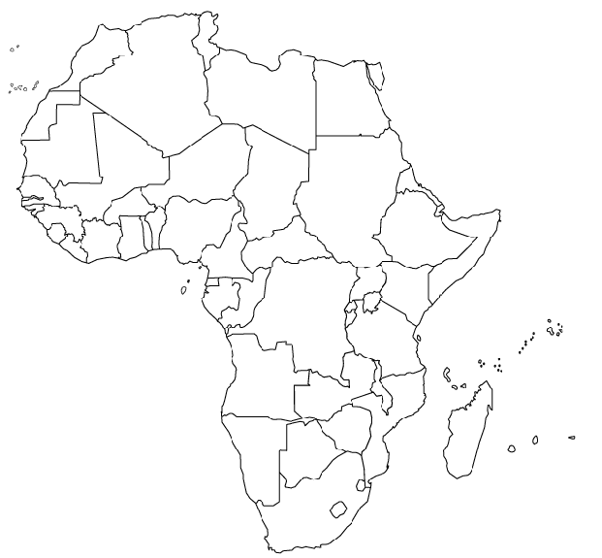

Map Key
Arab –

Ashanti –

Bantu –

Swahili -

