Nervous System Notes
How the Nervous System Works
Picture of a Neuron
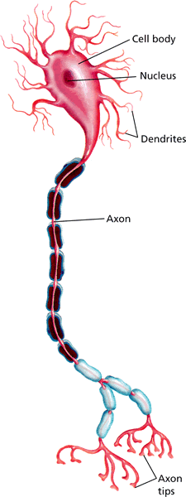
Functions
- Receiving Information: what is happening in and out of the body.
- Responding to information: stimulus and response.
- Maintaining Homeostasis

- A neuron has a large cell body that contains the nucleus, threadlike extensions called dendrites, and an axon.
- An impulse moves from the dendrites, through the axon, to the axon tips.
- For a nerve impulse to be carried along at a synapse, it must cross the gap between the axon and the next structure. The axon tips release chemicals that carry the impulse across the gap.
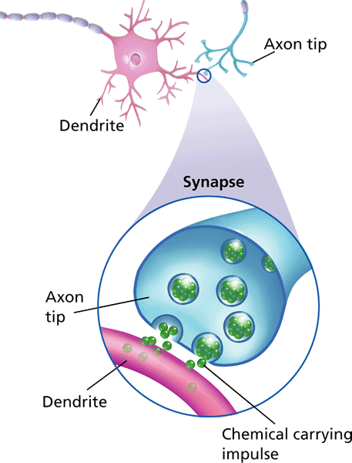

Divisions of the Nervous System
- The central nervous system is the control center of the body. It includes the brain and spinal cord.
  - There are three main regions of the brain that receive and process information. These are the cerebrum, the cerebellum, and the brain stem.
    - Cerebrum: receives information from the senses, controls movement, learning and remembering.
    - Cerebellum: coordinates muscle movement, maintains balance
    - Brain Stem: involuntary actions
- The peripheral nervous system consists of a network of nerves that branch out from the central nervous system and connect it to the rest of the body. The peripheral nervous system is involved in both involuntary and voluntary actions.
  - A reflex is a response that happens automatically.
  - A concussion is a bruise-like injury to the brain.
The Senses

Vision
- Your eyes respond to the stimulus of light. They convert that stimulus into impulses that your brain interprets, enabling you to see.
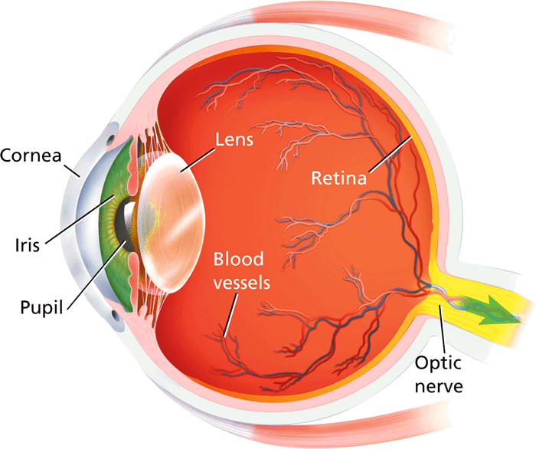
- Light coming from an object enters your eye and is focused by the lens. The light produces an upside-down image on your retina. Receptors in your retina then send impulses to your cerebrum, which turns the image right-side up.
Hearing and Balance
- Your ears are the sense organs that respond to the stimulus of sound. Ears convert the sound to nerve impulses that your brain interprets.
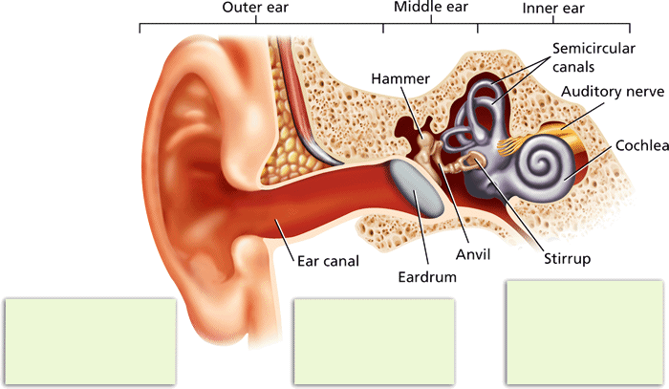
Smell and Taste
- The senses of smell and taste work closely together. Both depend on chemicals in food or in the air. The chemicals trigger responses in receptors in the nose and mouth.

