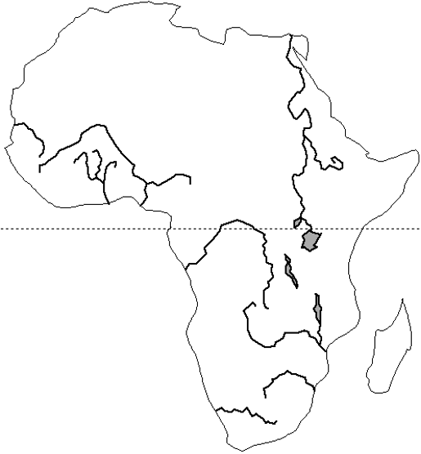

Mt. Kilimanjaro

Lake Victoria

The Sahel

Kalahari Desert

Great Rift Valley

Niger R.

Nile R.

Congo R.

Lake Tanganyika

Atlas Mts

Sahara Desert