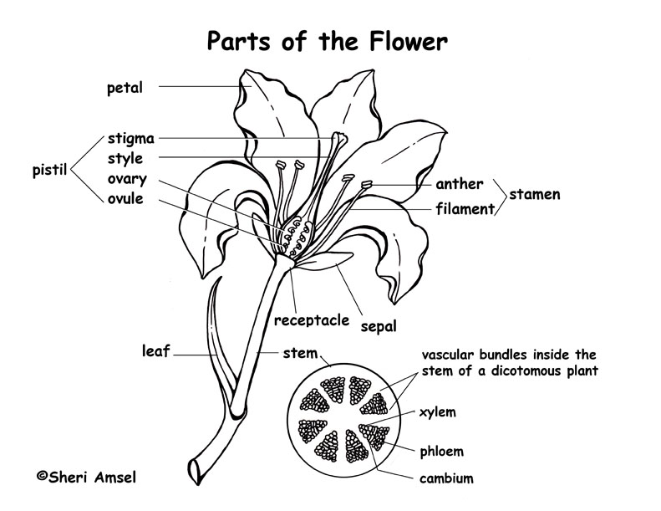

Plant reproduction
Most plants make seeds in order to keep their species going. Some plants put stickers on their seeds to make them stick to animals and humans. That's one way they travel. Some other seeds are very light, and have an aero-dynamic shape. This helps them to move in the wind. Most fruit trees' and shrubs' fruits grow with seeds in them so that when a bird, a human, or other animal eats the fruit, the seeds don't digest, and they come out sometime later.
The flower is the reproductive organ of a flowering plant. Many seed plants form seeds inside flowers. For reproduction to take place, pollen grains from the male _______________ must be carried to the female part of the flower, the _______________. Two ways that flowers are pollinated are by insects and by the wind. The insects like the bright petals and the sweet smell of the flowers. They land on the flowers to drink a liquid called _______________. When bees touch the stamen, _______________ sticks to the bees. When the bees move around the flower, pollen is transferred to the pistil. _______________ leads to the making of one or more seeds in a flower.
When seeds settle, have enough water, and have enough space to grow, they start to _______________. Once the _______________ starts to grow out of the seed, it also grows roots. It then is a young plant, and continues to grow.
Sources:
Science Horizons. Morriston, N. J. Silver Burdett Ginn.1993

