Landform Poem Instructions

- I will assign a landform from Southern and Eastern Asia to you.

- Together, you will compose a poem about your landform.

- The poem should be at least 10 lines long, and the poem should have 5 pairs of rhyming couplets.

- Your poem must contain a hand-drawn or a printed picture that relates to your landform.

- Final copies must be typed or in blue or black ink or marker.

- You will be presenting your poem on Monday.

Rubric
 | 4 | 3 | 2 | 1
Content | Poem represents the landform in an exceptional way. | Many aspects of the landform are represented. | Some aspects of the landform are represented. | Few aspects of the landform are represented.
Structure | Poem is the correct length with the correct numbers of couplets | The poem is missing 1-2 lines and/or rhyming couplets. | The poem has half the number of lines and/or rhyming couplets. | The poem has only 2-4 lines and/or rhyming couplets.
Illustration | Picture is present and represents the landform well. |  | Picture is present but doesn’t really represent the landform. | Picture is not present.
Grammar | Poem is free from grammatical, spelling, and punctuation errors | Poem has no more than 2 errors. | Poem has 3-5 errors | Poem has more than 5 errors in grammar, spelling, and punctuation.

Total:

Sahara Desert
By Brittney Black

The Sahara Desert is very hot and dry;
If you don’t wear sunscreen you might fry!

When you visit you must bring water,
because every year it gets hotter and hotter!

Located in Africa at the top,
not many people will you spot.

Desertification is taking over the land,
causing there to be lots of sand.

There is not much rainfall here each year,
which is causing Africa to have a growing fear.

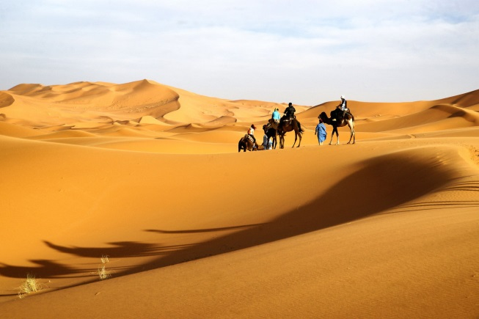

Tropical Rain Forest
By Stephanie Hosch

In the rain forest there is lush plant life;
Monkeys, gorillas, toucans, and frogs can there find a wife.

The typical weather is humid and hot;
90 inches of rain fall each year—that’s quite a lot!

In the canopy are butterflies galore!
50% of Earth’s animals and plants—who could want more?

The cure to cancer might be found here;
But people keep cutting down what we hold dear.

We must stop deforestation as soon can be;
Or the end of the rainforest could be the end of you and me!
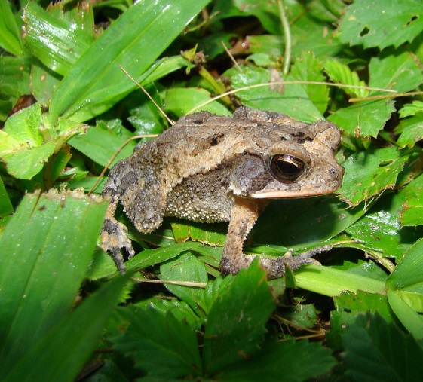
Landform Poem Instructions
- Get in groups two.

- I will assign a landform from Southern and Eastern Asia to your group.

- Together, you will compose a poem about your landform.

- The poem should be at least 10 lines long, and the poem should have 5 pairs of rhyming couplets.

- Your poem must contain a hand-drawn or a printed picture that relates to your landform.

- Final copies must be typed or in blue or black ink or marker.

- You will be presenting your poem on Monday. Each person in the group is responsible for reading at least two of the lines.

Rubric
 | 4 | 3 | 2 | 1
Content | Poem represents the landform in an exceptional way. | Many aspects of the landform are represented. | Some aspects of the landform are represented. | Few aspects of the landform are represented.
Structure | Poem is the correct length with the correct numbers of couplets | The poem is missing 1-2 lines and/or rhyming couplets. | The poem has half the number of lines and/or rhyming couplets. | The poem has only 2-4 lines and/or rhyming couplets.
Illustration | Picture is present and represents the landform well. |  | Picture is present but doesn’t really represent the landform. | Picture is not present.
Grammar | Poem is free from grammatical, spelling, and punctuation errors | Poem has no more than 2 errors. | Poem has 3-5 errors | Poem has more than 5 errors in grammar, spelling, and punctuation.

Total:

