There are many different forms of government in our world. Each looks a little bit different. The major difference lies in who is in control, but there are subtle differences that exist as well. Let’s explore different categories and forms of government…

Direct Democracy In a direct democracy all citizens have a chance to participate. The people directly control and are responsible for the laws that govern their society. All citizens can take initiative to create public policy. An example of a direct democracy is ancient Athens where they held assemblies to pass laws.
Democracy Any form of
government in which political power is exercised by all citizens, either directly or through their elected representatives. Have you ever been to vote with your parents?

Representative Democracy Like direct democracy, representative democracy is a government by the people.
Representative democracy is a form of government in which people elect leaders to write and manage laws for the country. These leaders are responsible for representing the will of the people and are elected at regular intervals. They are also often bound by a Constitution.

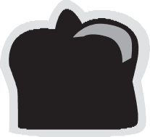
Monarchy Kings, queens, princes, and princesses. We all pretend when we’re little, but in a monarchy these roles are reality. Monarchy is rule by a king, or monarch, and he usually gains his power because his parents were rulers (monarchs) also. This applies to queens, too! Some modern monarchies like Spain and Japan have constitutions, while others do not.
Autocracy A form of
government in which political power is controlled by one individual such as a monarch, dictator, emperor, etc.
Dictatorship In a dictatorship power is not inherited, but usually is acquired by force. A dictator has absolute control over the lives of his citizens, like Kim Jong Il in North Korea. Because a dictator has absolute power, opposition is usually suppressed and people are prevented from voicing their opinions.

Theocracy The word theocracy contains the Greek root “theo” which means “god.” A theocracy is a rule by god or higher power. In a theocracy, religious leaders usually lead the society and religious law is used to settle disputes and rule the people. The Islamic Republic of Iran is an example of a modern theocracy.
Oligarchy The philosopher Aristotle originally used the word “oligarchy” to refer to rule by the rich, but the literal definition of oligarchy is “rule by the few.” This means that a few people hold all the power based on military strength (known as a military junta), family power (an aristocracy), or religious force (a theocratic oligarchy).
Oligarchies can often come from or lead to other forms of government like monarchies and dictatorships.

Anarchy In this form of government no one is in charge! Sounds too good to be true? Think about all the possible outcomes of having no government at all.

Enter the different forms of government in the left hand column. Then complete the following chart by placing a plus (+) under features that each form of government exhibits. Place a minus (-) under each feature not exhibited by each form of government. Use a question mark (?) if you’re not sure.

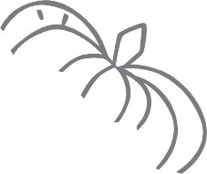
The Rules of Ruling
Forms of Government

 |  |  | Autocracy |  | Democracy |  | Features
 |  |  |  |  |  |  | Rule by few
 |  |  |  |  |  |  | Rule by one
 |  |  |  |  |  |  | Rule by representatives
 |  |  |  |  |  |  | Rule by none
 |  |  |  |  |  |  | Controlled by citizens
 |  |  |  |  |  |  | Ruled by god or higher power
 |  |  |  |  |  |  | Power usually inherited
 |  |  |  |  |  |  | Holds elections for leaders
 |  |  |  |  |  |  | Constitutional government
 |  |  |  |  |  |  | People have a say

Compare and contrast. Use the information you gathered on your chart on page 1 to complete the following graphic organizer with your analysis. Write your own for #6.

- Direct Democracy and Representative Democracy
are alike because
Analysis

- Oligarchy and Monarchy
are different in that

- Monarchy and Dictatorship
share the characteristic

- Monarchy and Dictatorship
are similar, but

- Autocracy and Democracy
are different because

- and

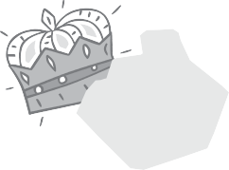
Characteristics. For each form of government and its characteristics, circle the one that doesn’t belong.
- Direct democracy: rule by the people / lead by a monarch / regular voting
- Anarchy: rule by the people / rule by no one / no laws
- Monarchy: rule by one / power inherited from family / regular elections
- Oligarchy: rule by few / military, religious, or family power / power always acquired by force
- Autocracy: monarch or dictator / power always inherited from family / never a Constitution

Magic Square. After reading “Who Rules?” match the correct definition to each term by writing the num- ber in the corresponding box below (ex. if the definition of A is number 1, write 1” in box A).

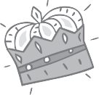
Terms Definitions

A.Democracy B.Dictatorship C.Direct Democracy D.Anarchy E.Monarchy F.Oligarchy G.Autocracy
H.Representative Democracy I.Theocracy
1.Rule by god or higher power 2.Rule by none
3.Rule by a single person who gained power through force 4.Rule by a king or queen
5.Rule by the citizenry or public without representatives 6.Rule by one
- Rule by the people
- Rule by the people with elected representatives 9.Rule by the few

To check your answers, add up the numbers in each row. Are they the same? Now add up the numbers in each column. They should be the same, too! What is the magic number?
A | B | C
D | E | F
G | H | I

If they don’t add up to the same number, go back and check your answers!

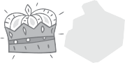

Your Opinion.
Which form of government do you think is the best?

List two reasons why you think that form of government is the best:
1.

2.

Which form of government do you think is the worst?

List two reasons why you think that form of government is the worst:

1.

2.

